EXECUTIVE SUMMARY
LEARNING TO READ PRIMARY SOURCE PHOTOGRAPHS WITHIN VIRTUAL EXHIBITS

Stéphane Lévesque, Ph.D. Stephane.levesque@uottawa.ca
Nicholas Ng-A-Fook, Ph.D. nnafook@uottawa.ca
Julie Corrigan, Doctoral candidate Julie.corrigan@uottawa.ca
University of Ottawa

CONTEXT
Students live in a visually saturated world. Today’s textbooks, virtual exhibits, and multimedia presentations are evidence of this visual shift in the presentation of educational content to students. But today’s visual sources – print or online – come in many different forms and are consumed for a plethora of purposes. One does not read the profile of a friend on Facebook in the same way as, for example, a photograph of 1950 residential school survivor.

To become a critical visual reader, students must develop their capacities to question how such texts were produced and what roles particular disciplinary domains of knowledge such as history can play in contextualizing forms of visual sources. But how does one come to read and think critically about visuals in the domain history?

PURPOSE
This study explores how pre-service teachers and historians alike make sense of historical photographs and consider, from an educational point of view, what their experiences tell us about disciplinary-specific visual literacy practices.

In our Virtual History Lab, using eye tracking technology and a think-aloud protocol, we studied the strategies some pre-service teachers and historians utilized to examine a series of online primary source photographs part of a virtual exhibit on Canadian residential schooling (www.wherearethechildren.ca).

FINDINGS
- Time spent reading the photographs as well as the gazetrail between the various visual components are directly linked to the overall quality of analysis.

- Participants who skimmed through the visuals swiftly and inconsistently did not offer any detailed or sophisticated readings, looking at straight, manifest features emerging from each source. (see Figure 1)

- Participants who drew upon different historical thinking strategies spent more time reading the photographs and in turn engaged the photographs with interpretations that went beyond the manifest information, analyzing the details and messages within the image (caption, pictorial details, scripts, etc.) to see how they are related to the whole and how they help understand manifest and latent meanings. (see Figure 2)

Figure 1: Passive historical reader
(eye fixation points with gazetrail)
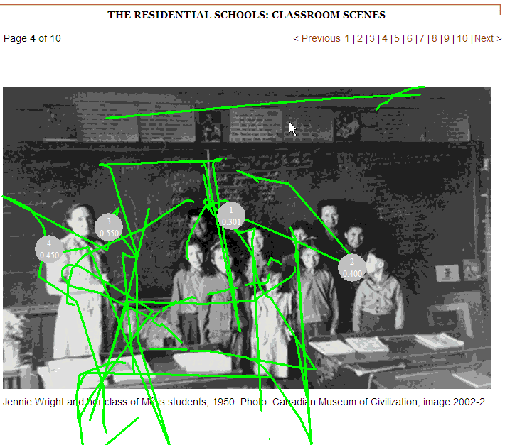

Figure 2: Practical historical reader
(eye fixation points with gazetrail)

- There is no standard reading pattern for making sense of visual historical sources. Both the verbal explanations and eye-tracking of participants demonstrate that photographs can be read in many different ways. Unlike traditional written texts, which follow an established reading pattern, the interaction between the reader and a visual is different because the image is there all at once and fills the page or the computer monitor.

- Equally interesting, the number and duration of eye fixations on visuals is a necessary, but not a sufficient condition for making sense of primary source photographs. Critical historical readers spend more time on photographs (see Figure 3) but bring something to the task that others do not. They have a deeper knowledge of history and make effective use of historical thinking in their analysis. Moreover, they can situate the sources (in terms of continuity and change and its significance) in a larger historical context – a “big picture.” Overall, they have more agency to interpret the visuals because they can draw on vast knowledge and historical experience.

Figure 3: Critical historical reader
(eye fixation points with gazetrail)

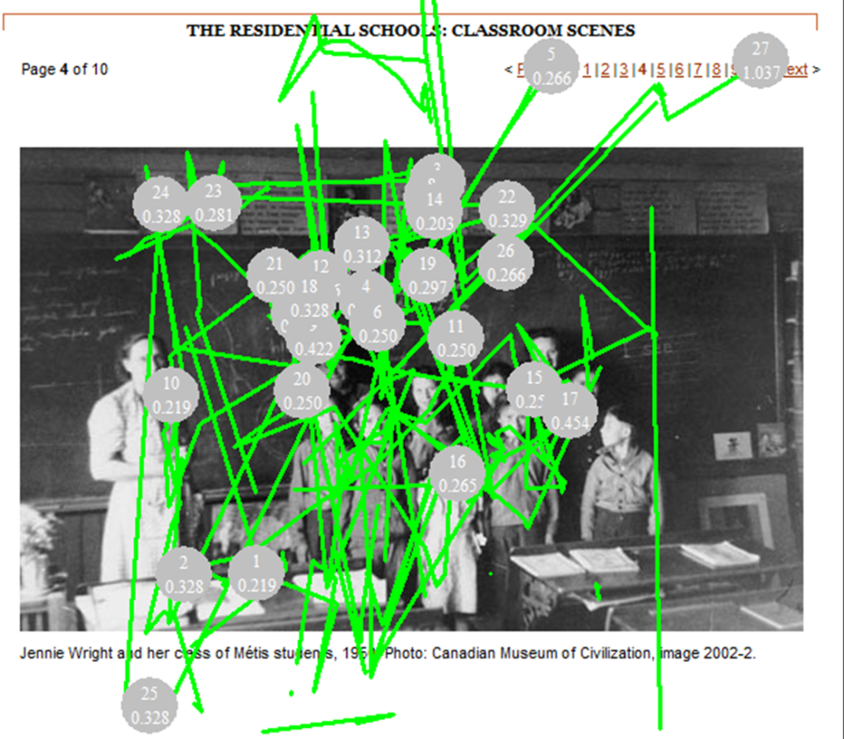

EDUCATIONAL RECOMMENDATIONS
- Prior knowledge assumptions about visual texts
Our findings suggest that learners read visual primary sources in a virtual environment with pre-conceived ideas about images and the Web that we dubbed the “Google reflex.”
Educators need to take into account more seriously how they use or encourage students to make use of visuals in the classroom. Too often, PowerPoint presentations, virtual exhibit tours, or unit projects favour the inclusion of visual sources to enrich the learning experience without thinking about how learners will read them beyond mere illustrations.
- The need to “expand” and “break down” images
Visual primary sources are more than things or icons. The meanings of these historical texts emerge during the interaction between the visual and the reader. Images are “stopped action frames” in a narrative. To understand what is taking place, readers need to look at both the antecedent as well as the consequence of the actions being represented. This narrative view of visuals implies that readers must expand the reading of an image to look at the larger historical context, asking such questions as: What larger issues, values or events does this image present? How does the image represent people of the period? In what ways does the image compare/contrast with today?
The reading of visual texts also implies a close inspection and decoding of the various parts of an image. Images are not like print texts with a standardized reading pattern. Because the visual is there all at once, it is important for readers to consider carefully the many elements that compose it (e.g., persons, objects, buildings, scripts, captions, etc.), asking such questions as: What are people doing? What does the caption tell us about the image? How is the caption orienting our reading of it? Is there a date and reference? Can these help us contextualize the source in time?
- The photographer and the “click” of the camera
Like any other text, visuals are authored. They were created by photographers who wanted to convey particular messages about the events and actors of the time. Choices were deliberately made in conceptualizing and producing the images.

Educators need to encourage readers to develop a “reflexive reading” (Werner, 2002), which calls for evaluative meaning and self-awareness of the visual sources. Critical reflexive readers recognize, evaluate and potentially contest the ways in which visuals position the readers. They do so by raising such questions: In what position is the reader placed (e.g., the teacher, the inspector, the student, the parent)? In what roles (e.g., as participant in the event? as witness? as sympathizer?) What strategies and devices were used to create the desired effect? What impact do our present-day perspectives and values have on our ability to read this image from the past?

Full version of this study will appear in:
Lévesque, S., Ng-A-Fook, N, & Corrigan J. (2014). What does the eye see? Reading online primary source photographs in history. Contemporary Issues in Teacher Education, 14(2). Available from : http://www.citejournal.org/vol14/iss1/

For more information on this paper or our study, contact:

Prof. Stéphane Lévesque
Faculty of Education
University of Ottawa
145 Jean-Jacques Lussier
Ottawa ON CANADA
K1N 6N5
stephane.levesque@uottawa.ca

This study for funded by the Social Science and Humanities Research Council of Canada (2011-2013).

